Volatility correlation: USDCAD and EURGBP
Method 25 / daily |log returns| / rho_vol / Alpari D1 full available history (realized deferred)

Study setup
Logical pair: USDCAD , EURGBP
Broker symbols: USDCAD_i , EURGBP_i
Snapshot: 2026-11-03_majors_alpari_D1
Timeframe: D1
Matched return window: 1999-01-06 to 2026-11-02 (UTC bar dates)
Matched return count n: 7185
Dropped unfinished last bar dated 2026-11-03 UTC after a tick-volume check against the prior complete day.
Statistic: rho_vol = Corr(|log return_L|, |log return_R|)
rho_realized: not computed (no intraday buckets in this snapshot)
Complete matched rows (Excel): USDCAD-EURGBP_Vol_D1.xlsx
Complete matched rows (HTML table): USDCAD-EURGBP_Vol_D1_data.html

Method carried forward
Volatility correlation rho_vol = Corr(|x_t|, |y_t|) measures whether absolute daily log returns of close move together in size, regardless of sign. Quotes are not inverted. Same-sample signed Pearson r is a side check. The formula sheet also defines within-day realized correlation rho_realized,d from intraday buckets; this v001 uses the Alpari D1 snapshot only, so rho_realized is not computed (no intraday buckets). This is not causation and not a trading signal.

Results (headline)
rho_vol: 0.191552
Pearson r (signed): -0.014622
mean |USDCAD|: 0.00373273
mean |EURGBP|: 0.00353837
rho_realized: n/a (D1-only snapshot)

Conclusion
Headline rho_vol for USDCAD and EURGBP: 0.1916. Signed Pearson r = -0.0146. Mean |return|: 0.003733 (USDCAD), 0.003538 (EURGBP). rho_realized not computed (D1 snapshot has no intraday buckets). This is absolute-move co-movement, not a trading signal.

Charts
Daily closes

Daily log returns

Absolute returns scatter
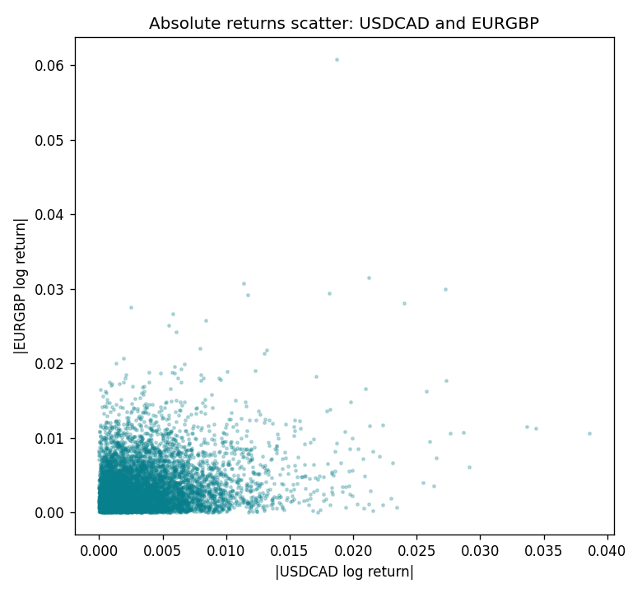

Data report
Matched rows are in the sibling Excel workbook named USDCAD-EURGBP_Vol_D1.xlsx. Embedding all rows as a Word table is impractical; this file holds column summaries and the first and last 15 matched rows.
Columns: time, USDCAD_open, EURGBP_open, USDCAD_high, EURGBP_high, USDCAD_low, EURGBP_low, USDCAD_close, EURGBP_close, USDCAD_tick_volume, EURGBP_tick_volume, USDCAD_spread, EURGBP_spread, USDCAD_real_volume, EURGBP_real_volume, USDCAD_log_return, EURGBP_log_return, USDCAD_abs_return, EURGBP_abs_return
Column summaries (matched calculation rows)
column | count | mean | std | min | 25% | 50% | 75% | max
USDCAD_open | 7185 | 1.2666594 | 0.16886861 | 0.9168 | 1.1183 | 1.29841 | 1.37203 | 1.6183
EURGBP_open | 7185 | 0.78693389 | 0.09666561 | 0.5734 | 0.6876 | 0.83387 | 0.86521 | 0.9769
USDCAD_high | 7185 | 1.2715589 | 0.16882635 | 0.9336 | 1.1227 | 1.30381 | 1.3764 | 1.619
EURGBP_high | 7185 | 0.79000929 | 0.09704455 | 0.5789 | 0.6896 | 0.8369 | 0.8681 | 0.9799
USDCAD_low | 7185 | 1.2621046 | 0.16891061 | 0.9056 | 1.11396 | 1.29347 | 1.36776 | 1.6102
EURGBP_low | 7185 | 0.78423344 | 0.09648411 | 0.5682 | 0.6855 | 0.83166 | 0.86287 | 0.9661
USDCAD_close | 7185 | 1.2666836 | 0.16885076 | 0.916 | 1.118 | 1.29833 | 1.3723 | 1.6137
EURGBP_close | 7185 | 0.78697576 | 0.09666885 | 0.5735 | 0.6878 | 0.83391 | 0.86533 | 0.977
USDCAD_tick_volume | 7185 | 81049.359 | 147325.09 | 37 | 5563 | 40946 | 71633 | 1410818
EURGBP_tick_volume | 7185 | 87109.869 | 145486.28 | 154 | 6553 | 44326 | 81375 | 1424684
USDCAD_spread | 7185 | 23.430202 | 18.259258 | 0 | 9 | 17 | 40 | 60
EURGBP_spread | 7185 | 21.335421 | 19.123862 | 0 | 4 | 13 | 40 | 50
USDCAD_real_volume | 7185 | 1.8384377e+10 | 9.670755e+10 | 0 | 0 | 0 | 0 | 2.5751613e+12
EURGBP_real_volume | 7185 | 2.7864528e+10 | 1.3519652e+11 | 0 | 0 | 0 | 0 | 3.5726265e+12
USDCAD_log_return | 7185 | -8.08e-06 | 0.00514591 | -0.03859748 | -0.00283484 | 5.597e-05 | 0.00272835 | 0.03436319
EURGBP_log_return | 7185 | 1.874e-05 | 0.00486681 | -0.03067367 | -0.00262366 | -0.00010035 | 0.00255918 | 0.06075387
USDCAD_abs_return | 7185 | 0.00373273 | 0.00354193 | 0 | 0.00124189 | 0.00279907 | 0.00508718 | 0.03859748
EURGBP_abs_return | 7185 | 0.00353837 | 0.00334132 | 0 | 0.00119599 | 0.00260332 | 0.00485438 | 0.06075387
First 15 matched rows (selected columns)
time | USDCAD_log_return | EURGBP_log_return | USDCAD_abs_return | EURGBP_abs_return
1999-01-06 | -0.0003306769 | -0.013303338 | 0.0003306769 | 0.013303338
1999-01-07 | 0.0015202092 | 0.011051402 | 0.0015202092 | 0.011051402
1999-01-08 | -0.0020495197 | -0.004943862 | 0.0020495197 | 0.004943862
1999-01-11 | -0.0035137769 | -0.0012752393 | 0.0035137769 | 0.0012752393
1999-01-12 | 0.0066194721 | 0.0033970309 | 0.0066194721 | 0.0033970309
1999-01-13 | 0.0045420214 | 0.00042381861 | 0.0045420214 | 0.00042381861
1999-01-14 | 0.0069376546 | -0.0019793588 | 0.0069376546 | 0.0019793588
1999-01-15 | -0.0056905671 | -0.0076715819 | 0.0056905671 | 0.0076715819
1999-01-18 | 0.00098344542 | 0.00071280921 | 0.00098344542 | 0.00071280921
1999-01-19 | 0.002748513 | -0.0014261269 | 0.002748513 | 0.0014261269
1999-01-20 | -0.0059646885 | 0.0019960086 | 0.0059646885 | 0.0019960086
1999-01-21 | -0.0042823796 | -0.00071240297 | 0.0042823796 | 0.00071240297
1999-01-22 | 0.0025057712 | -0.0017118406 | 0.0025057712 | 0.0017118406
1999-01-25 | 0.00085579808 | -0.0054402425 | 0.00085579808 | 0.0054402425
1999-01-26 | 0.0001973879 | -0.00057438255 | 0.0001973879 | 0.00057438255
Last 15 matched rows (selected columns)
time | USDCAD_log_return | EURGBP_log_return | USDCAD_abs_return | EURGBP_abs_return
2026-10-13 | -0.0046395653 | 0.00020130374 | 0.0046395653 | 0.00020130374
2026-10-14 | 0.0015184751 | 0.0011241873 | 0.0015184751 | 0.0011241873
2026-10-15 | -0.0036101503 | -0.00087557391 | 0.0036101503 | 0.00087557391
2026-10-16 | -0.0034322068 | -0.0020380844 | 0.0034322068 | 0.0020380844
2026-10-19 | -0.0018835331 | -0.00056950988 | 0.0018835331 | 0.00056950988
2026-10-20 | -0.0037066008 | -0.0035906254 | 0.0037066008 | 0.0035906254
2026-10-21 | -0.00084691787 | -0.00140647 | 0.00084691787 | 0.00140647
2026-10-22 | -0.0026307268 | -0.0018743924 | 0.0026307268 | 0.0018743924
2026-10-23 | 2.85545e-05 | 0.00082421033 | 2.85545e-05 | 0.00082421033
2026-10-26 | 5.7106554e-05 | 0.00013133309 | 5.7106554e-05 | 0.00013133309
2026-10-27 | 0.0025379458 | -0.0019957343 | 0.0025379458 | 0.0019957343
2026-10-28 | -0.0038379274 | 0.00066967224 | 0.0038379274 | 0.00066967224
2026-10-29 | -0.00011436495 | -0.0011722209 | 0.00011436495 | 0.0011722209
2026-10-30 | -0.0010298736 | -0.0024205543 | 0.0010298736 | 0.0024205543
2026-11-02 | 0.00061519094 | 0.00089940465 | 0.00061519094 | 0.00089940465

